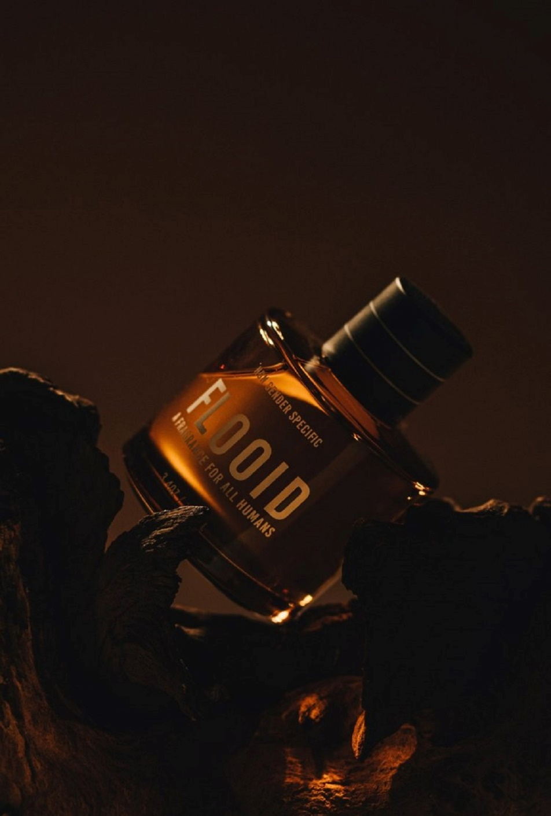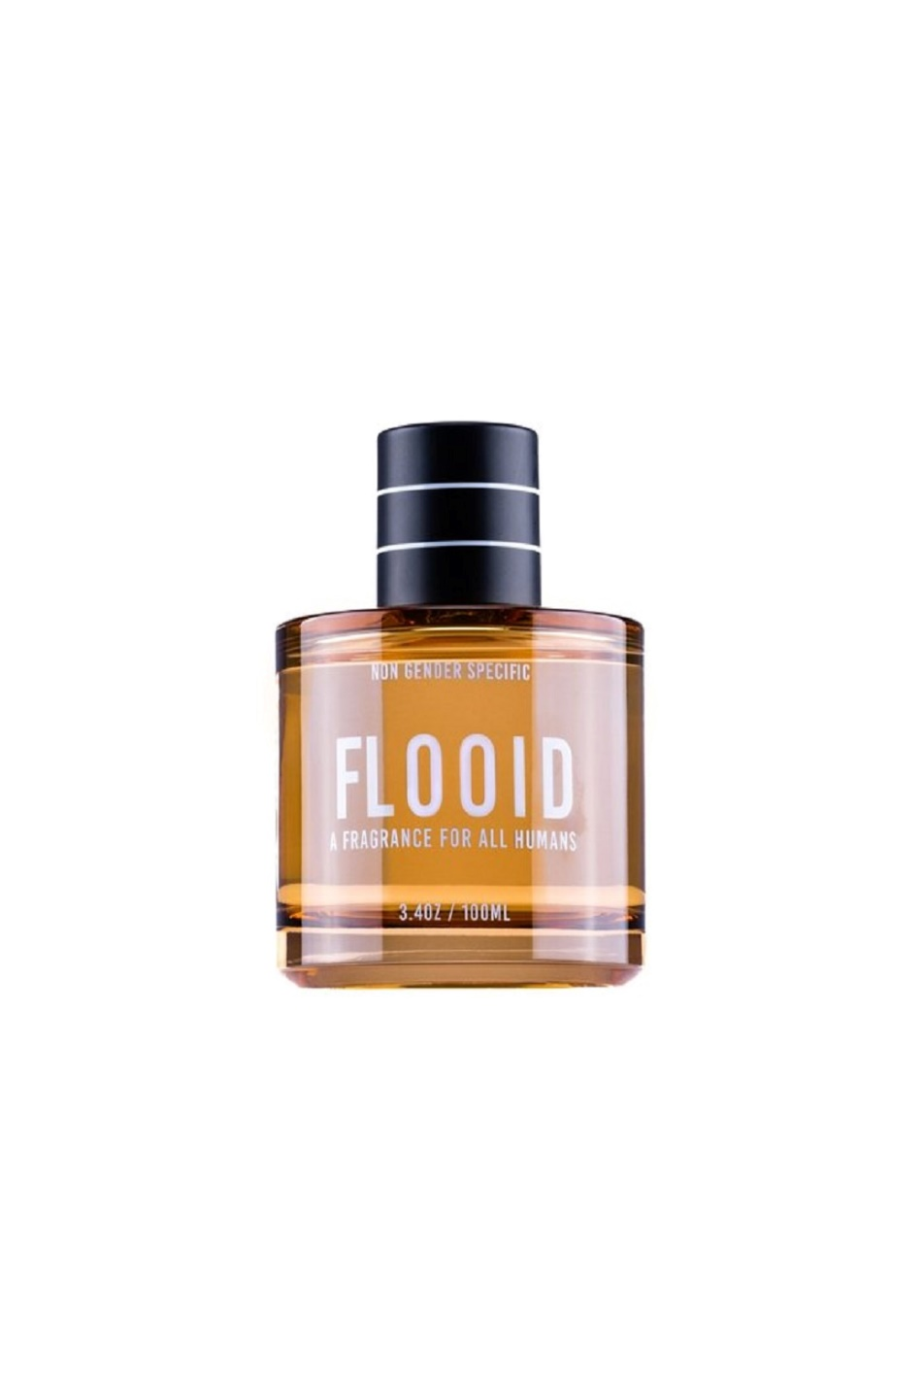

Flooid

PKR 7,000

Tax Included.

100 mL

IN STOCK

Product Details:

With Flooid, embark on a transformative olfactory adventure, where gender norms are left behind, and nature takes center stage. It's time to embrace a fragrance that knows no boundaries, a fragrance that harmonizes with your individuality and resonates with your soul. Rediscover the essence of simplicity, solace, and pure beauty with Flooid, the epitome of a genderless fragrance.

Flooid weaves together a harmonious symphony of scents, artfully combining warm, earthy notes with a refreshing twist. Like the intertwining vines around a tree, its dynamic aroma twists and bends, revealing layers of complexity that envelop your senses. With every spray, Flooid invites you on a journey, transporting you to a place of tranquility and simplicity.